✅ GitHub Link: https://github.com/NaveenOVN/Brain-Tasks-App
✅ LoadBalancer ARN: arn:aws:elasticloadbalancing:ap-south-1:792682046782:loadbalancer/a90a6a6edb4de4783a5f3582f89e3989
docker build -t brain-tasks-app:latest
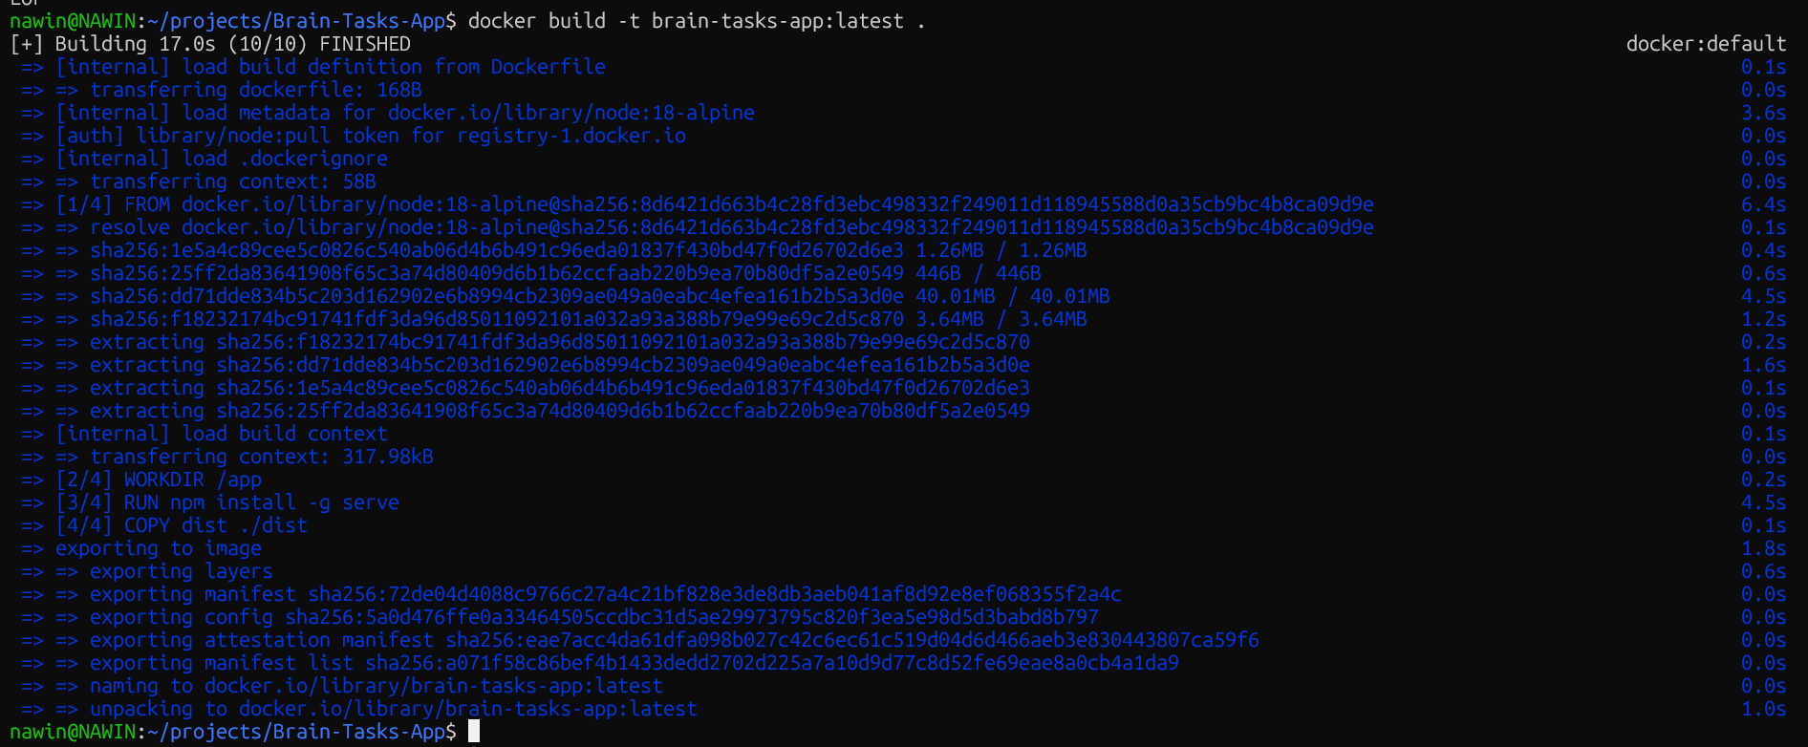
curl -I http://localhost:3000
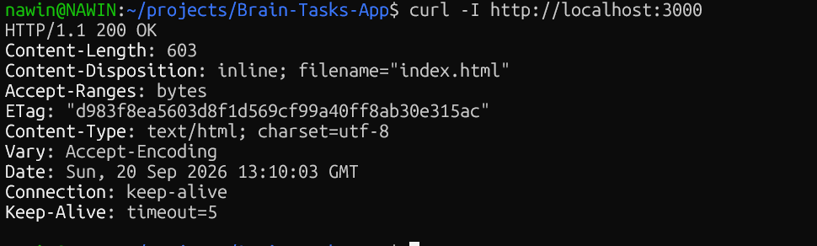

kubectl get nodes

kubectl get pods
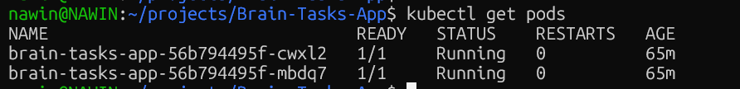
kubectl get svc brain-tasks-service
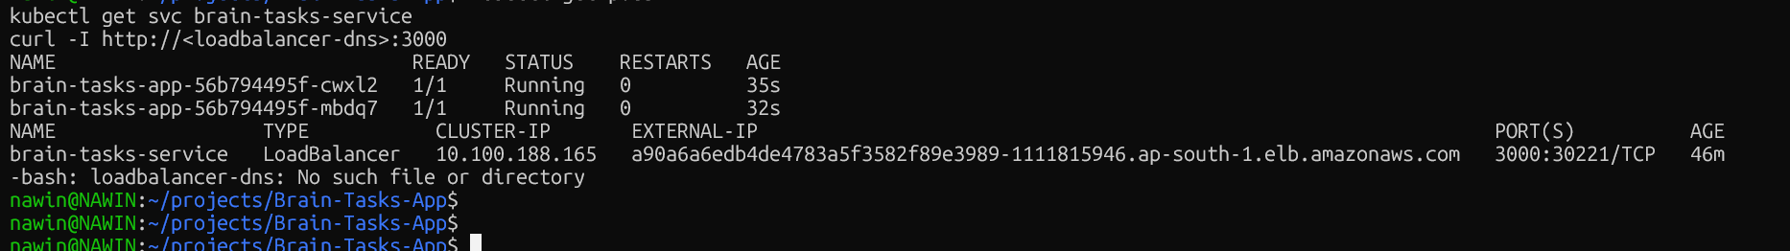
brain-tasks-build
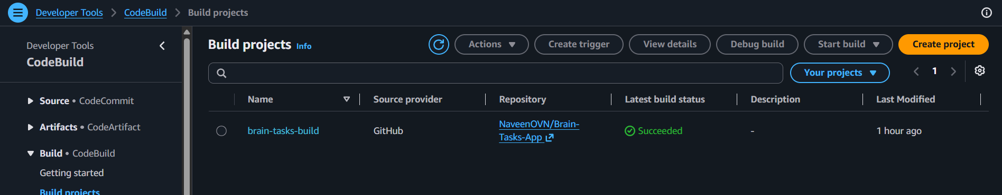
brain-tasks-pipeline
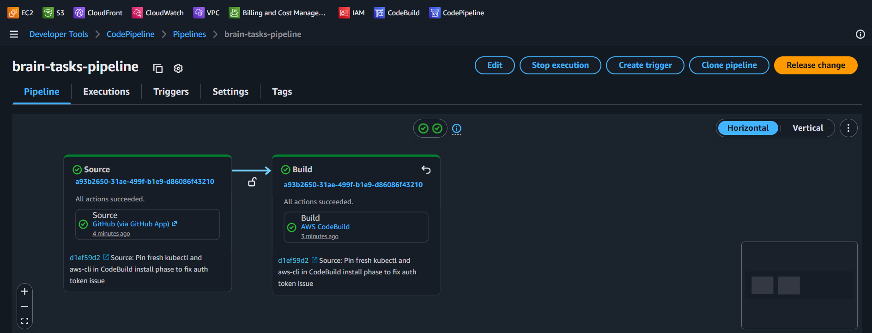

kubectl get pods -n amazon-cloudwatch
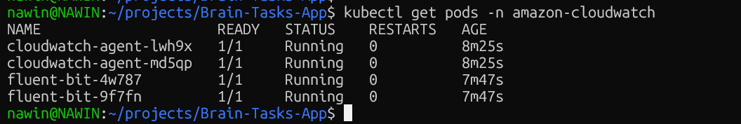

http://a90a6a6edb4de4783a5f3582f89e3989-1111815946.ap-south-1.elb.amazonaws.com:3000
